**More C# Programming and Unity**

**Week 1**

*Arrays*

* We can store one type of data type in a single array e.g. gameObjects or ints
* Array contains elements at indexes.
* E.g. GameObject[] prefabCharacters = new GameObject[4]; //declaring the array in fields of size 4
* In the inspector of main camera, we will see an array area. Drag prefabs from hierarchy window, and drop them on each element in the array inspector area, to add a single character in each index spot.
* Whenever we have to use elements of an array in our code, we will use prefabCharacters[0] etc…according to whatever indexed element we want to access.
* We declare objects inside by int[] scores = {0,4,5,6,3} or by scores[0] = 0; etc.

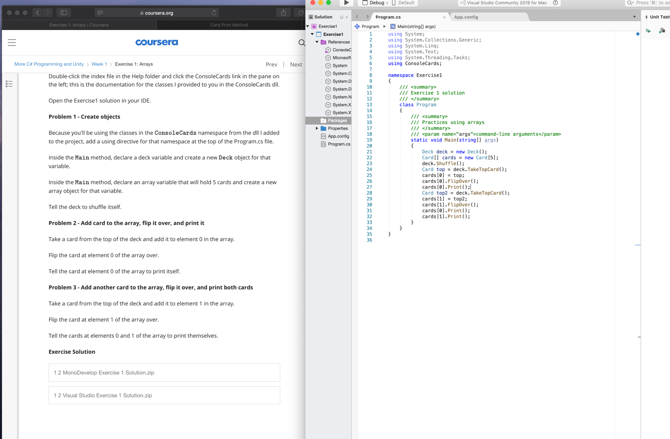

*Lists*

* Lists have elements and indexes too.
* List<GameObject> prefabCharacters = new List<GameObject>(); //<> include data types…similar to arraylists
* We must add using System.Collections.Generic; in the top if we want to use lists
* List will add and grow or shrink, unlike arrays.
* prefabCharacters.Add(character1); //to add in a list, again similar to arraylist
* For normal methods that don’t add something, we use array-like syntax. E.g. card[0].Print(); or card[1].FlipOver();

*Adding a DLL*

* + Dynamic Link Library
  + These are classes that we can create separately and then attach to our main c# file

*For Loops*

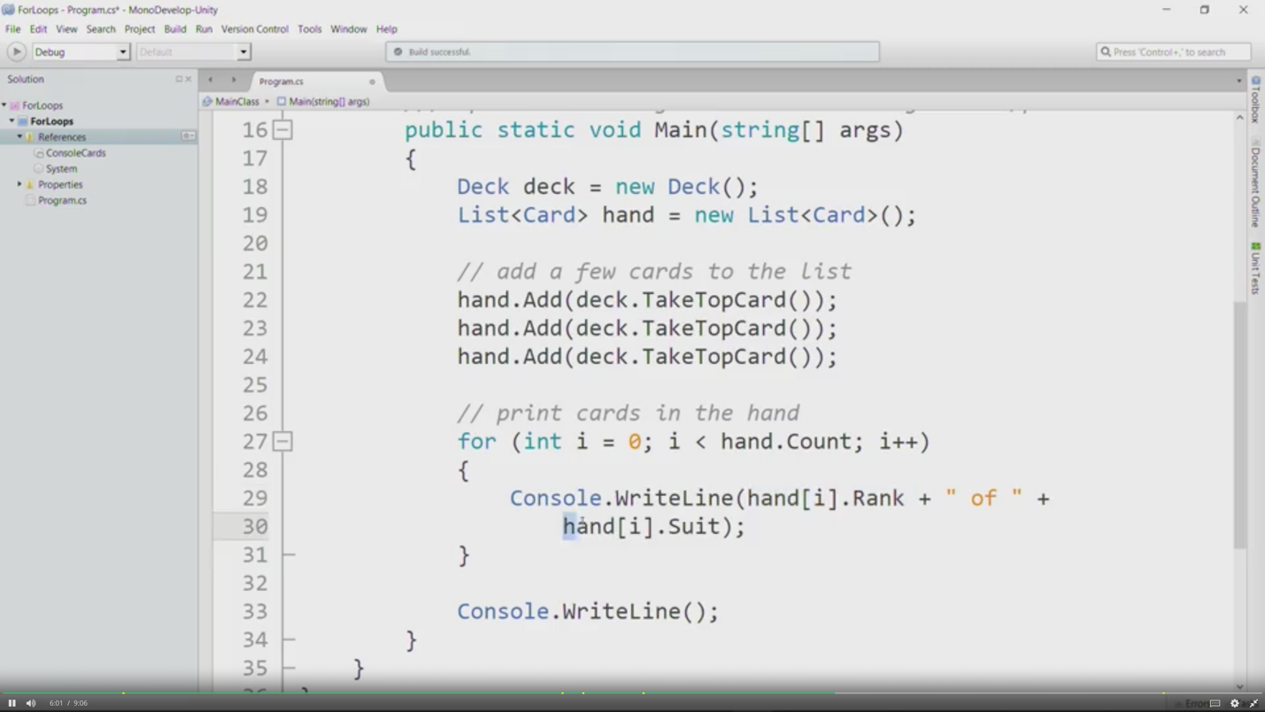

*Foreach Loops*

* In C#, for iterating over a list or an array, its better to use a foreach loop.
* Syntax is different. (data type of array/list and name of a created object + in + list/array name)

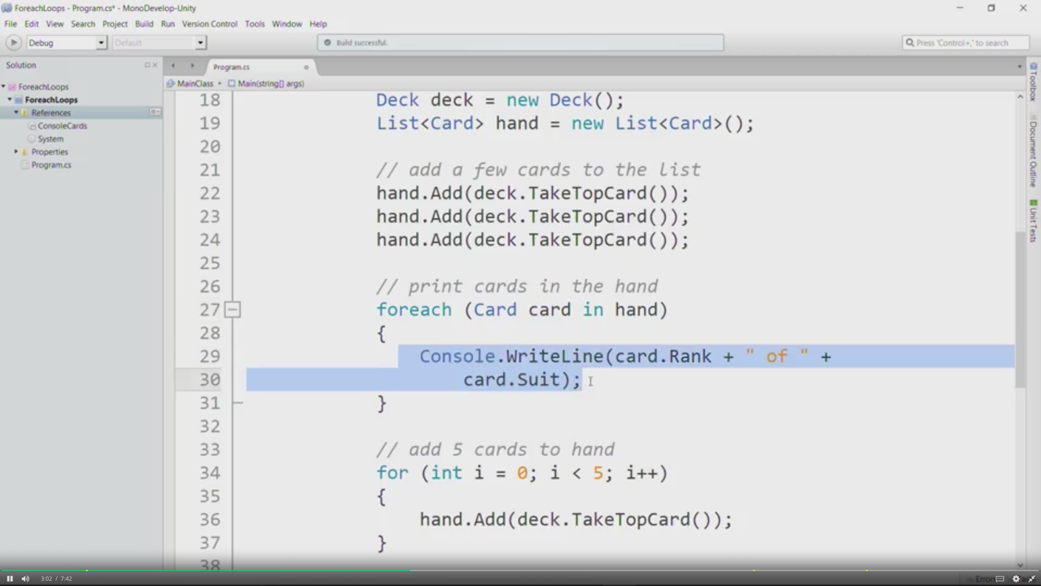

* In lists, we cannot add or remove using foreach loop.

*While Loops*

* 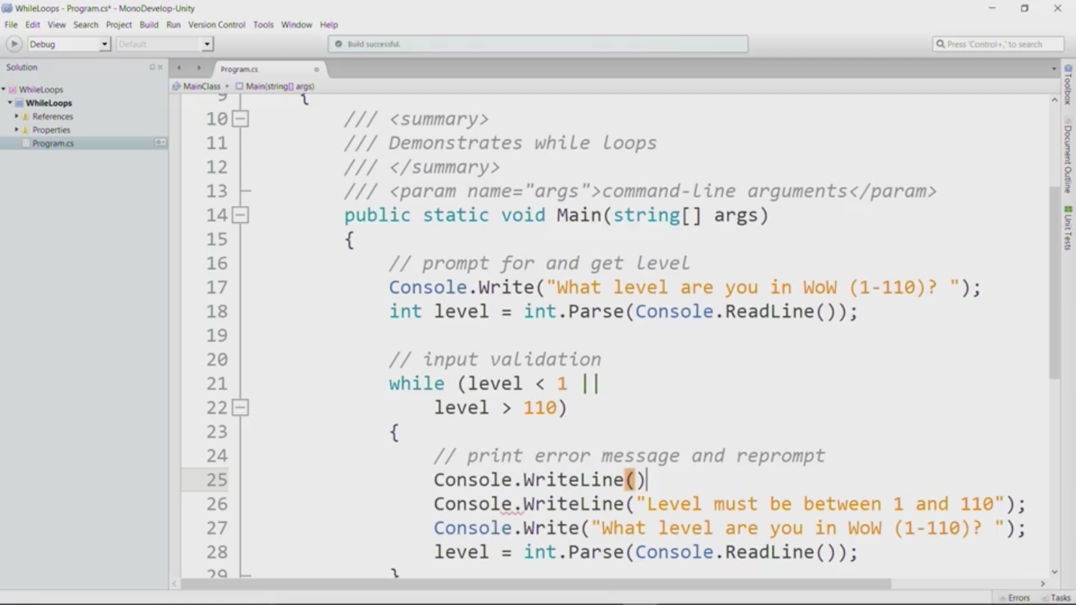

Week 2

Abstraction

* The most important details e.g. for a concert seat (location and quantity is important but color of seat is not)
* Implementation method is classes

Classes

* Fields deal with states and methods deal with behavior
* Properties can be used to deal with fields
* Instantiation deals with identity..to create new objects and give them their memory address
* Over here in the solution pane, we'll right click the project name which is

this bold faced whatever and I'm going to say,

Add a New File.

And by default, my new file is an EmptyClass.

I'm going to change the name of that EmptyClass to

Whatever we need and I'll click New.

As you can see,

we get a new template for our class

Fields and Properties

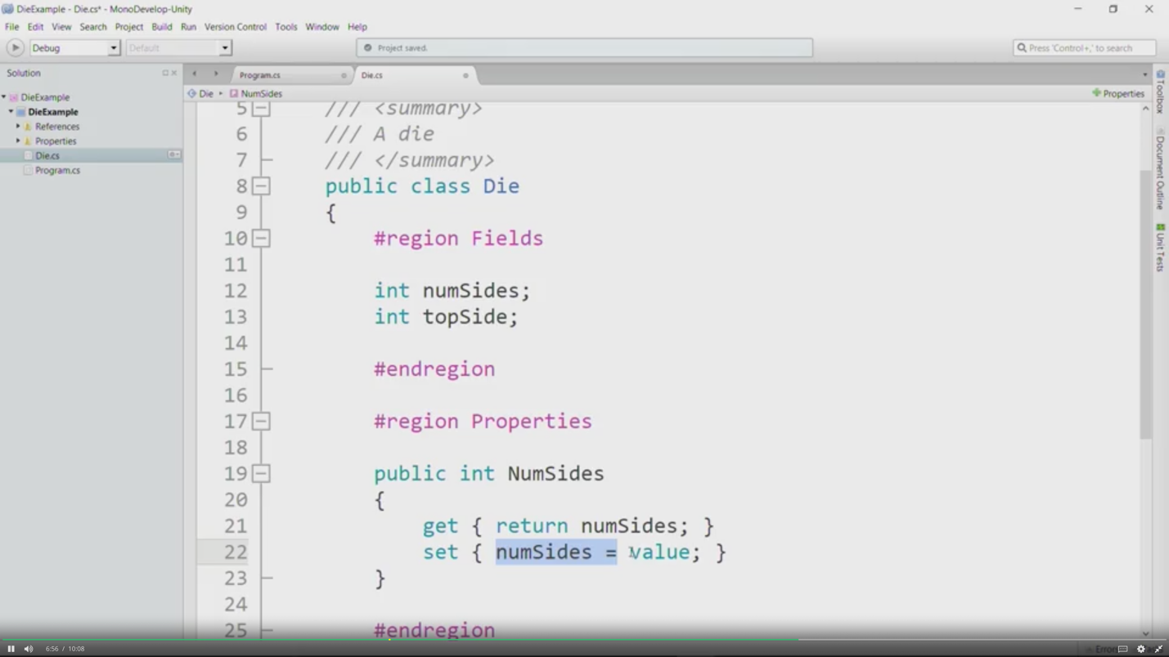

// we infact, need to remove the set one, because we don’t want others to change our dice number sides.. top side property will be identical to this one

Constructor

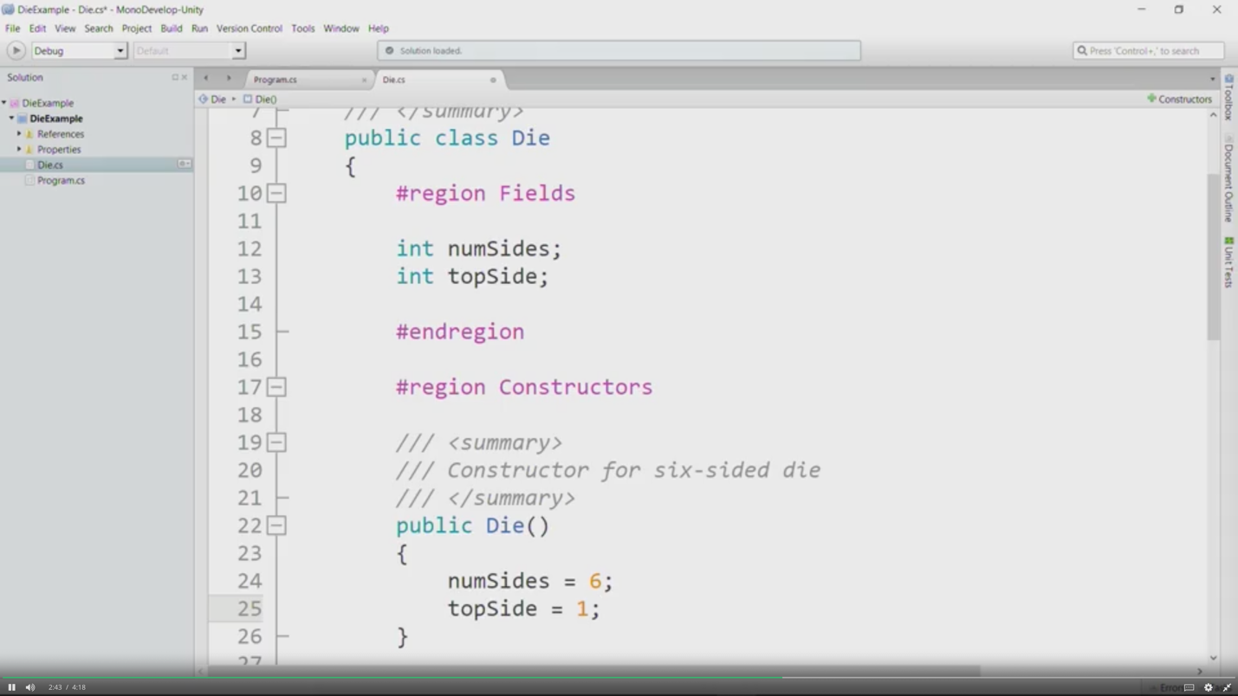

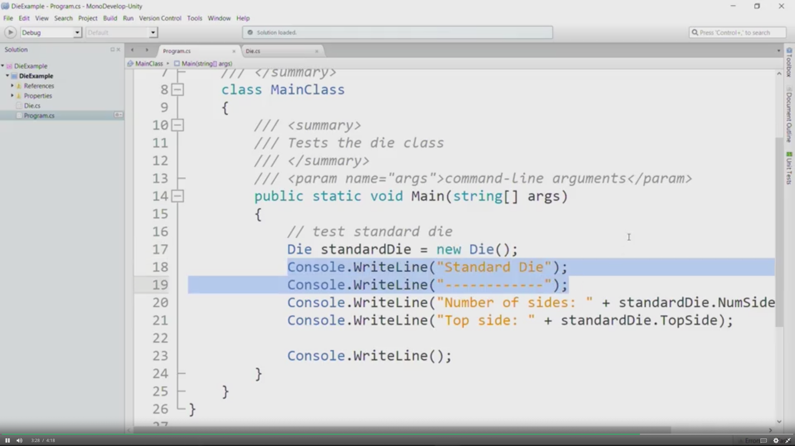

We can also place 2 constructors

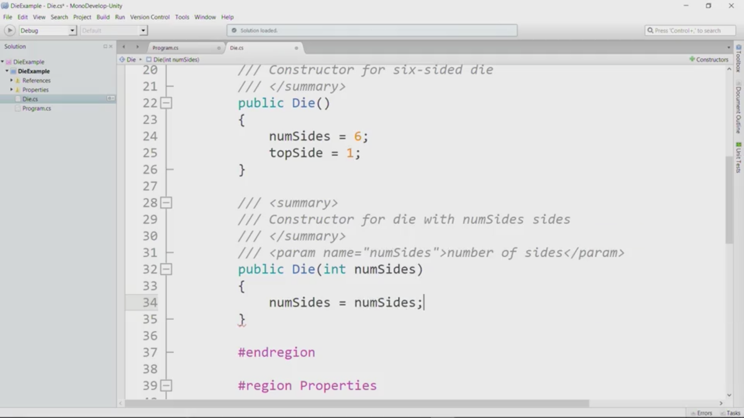

//its better to name the variable in the parameter with a different name..i.e. newNumSides and then do numSides = newNumSides;

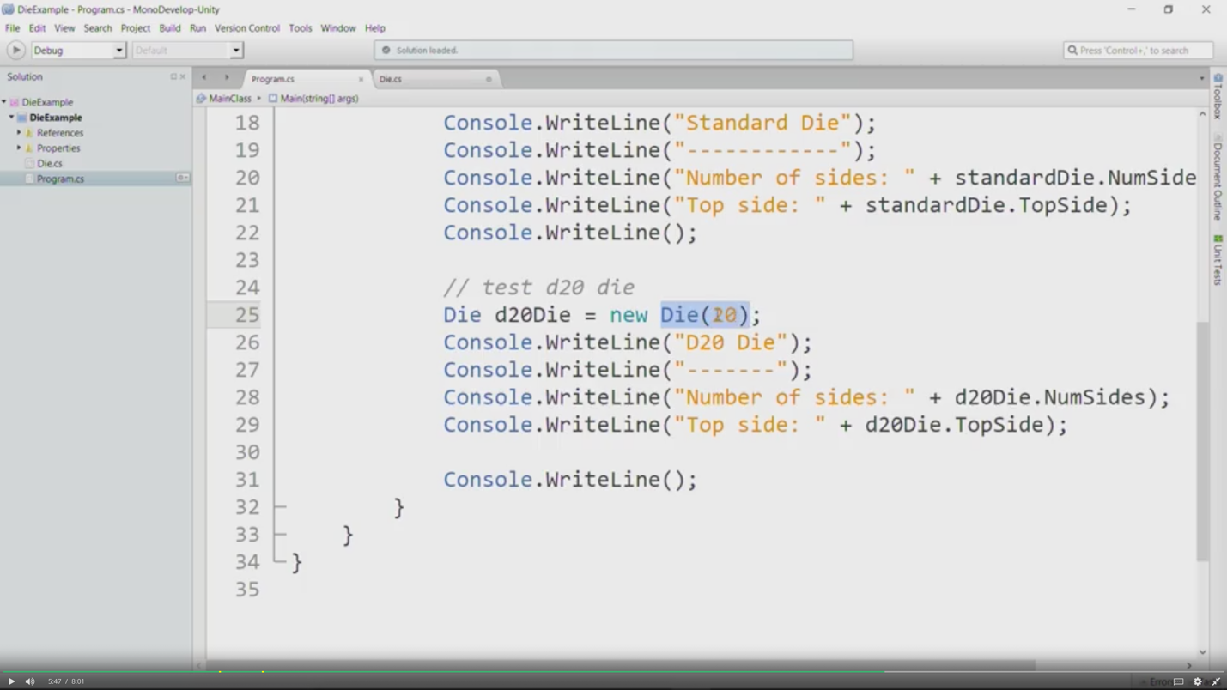

Methods

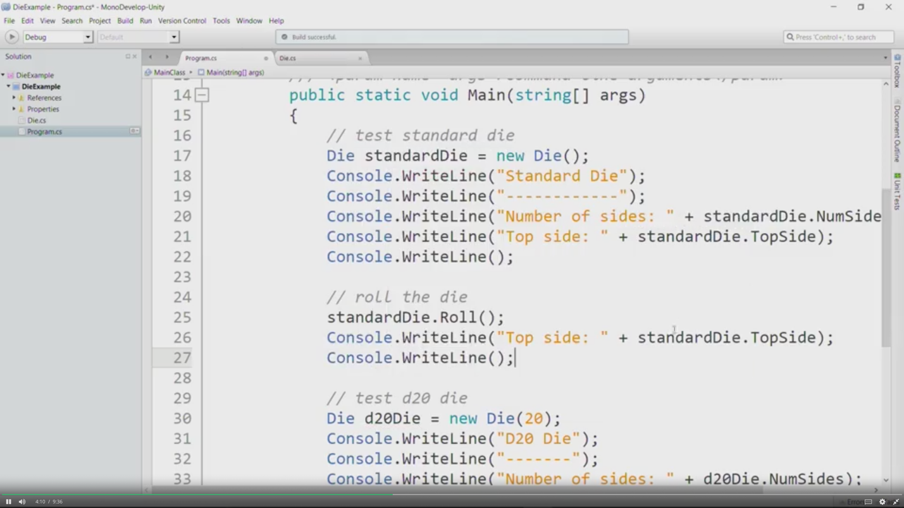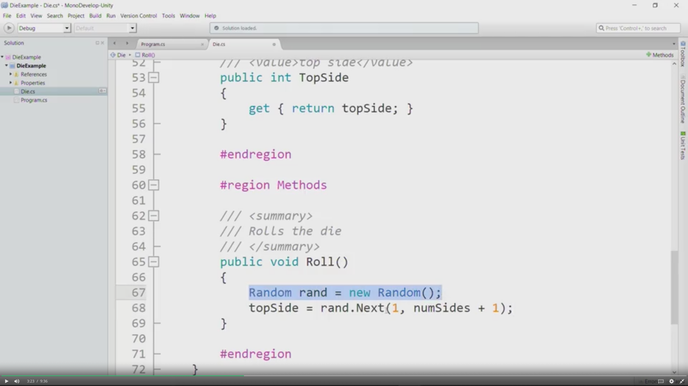

//we can also put Random rand = new Random() in the fields area, so we don’t have to write it again and again in our methods.

Week 3

*Method Headers*

* A method header tells us who can call the method,

it tells us whether the method is called on an object or a class,

it tells us what data type the method returns,

it gives us the method name,

and finally, it tells us

what information we pass into the method when we call the method.

Unity: Designing the Class

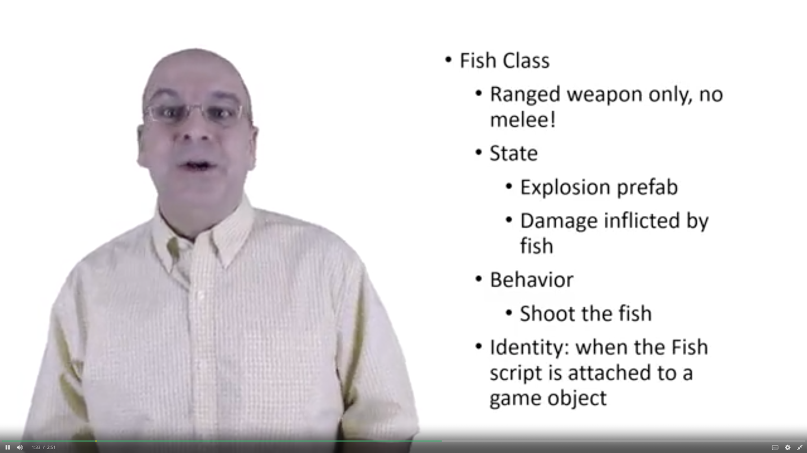

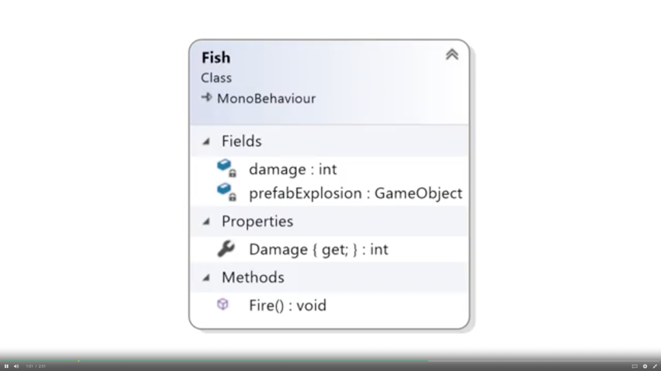

Unity: Fields and Properties

* Create a Fish prefab by dragging fish sprite in the hierarchy window
* Add an explosion sprite and an explosion script.
* Create a fish script and attach it to that fish prefab
* Edit the fish script.

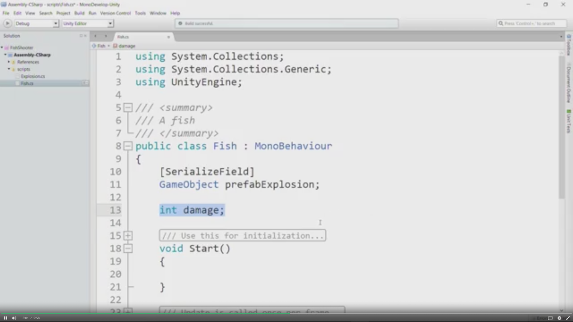

// give a random value to damage field..i.e. int damage = 100;

* Drag explosion prefab to the prefabExplosion in the inspector of fish script.
* Add properties in the fish script.

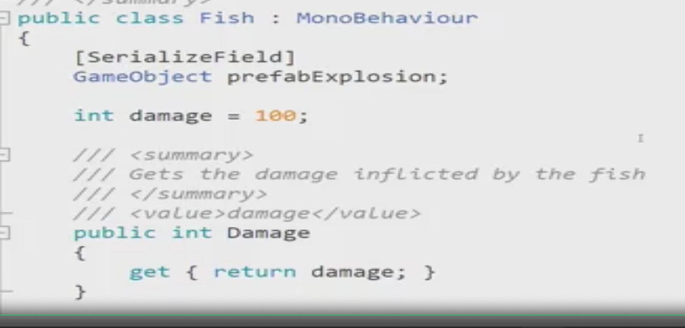

Unity: Methods

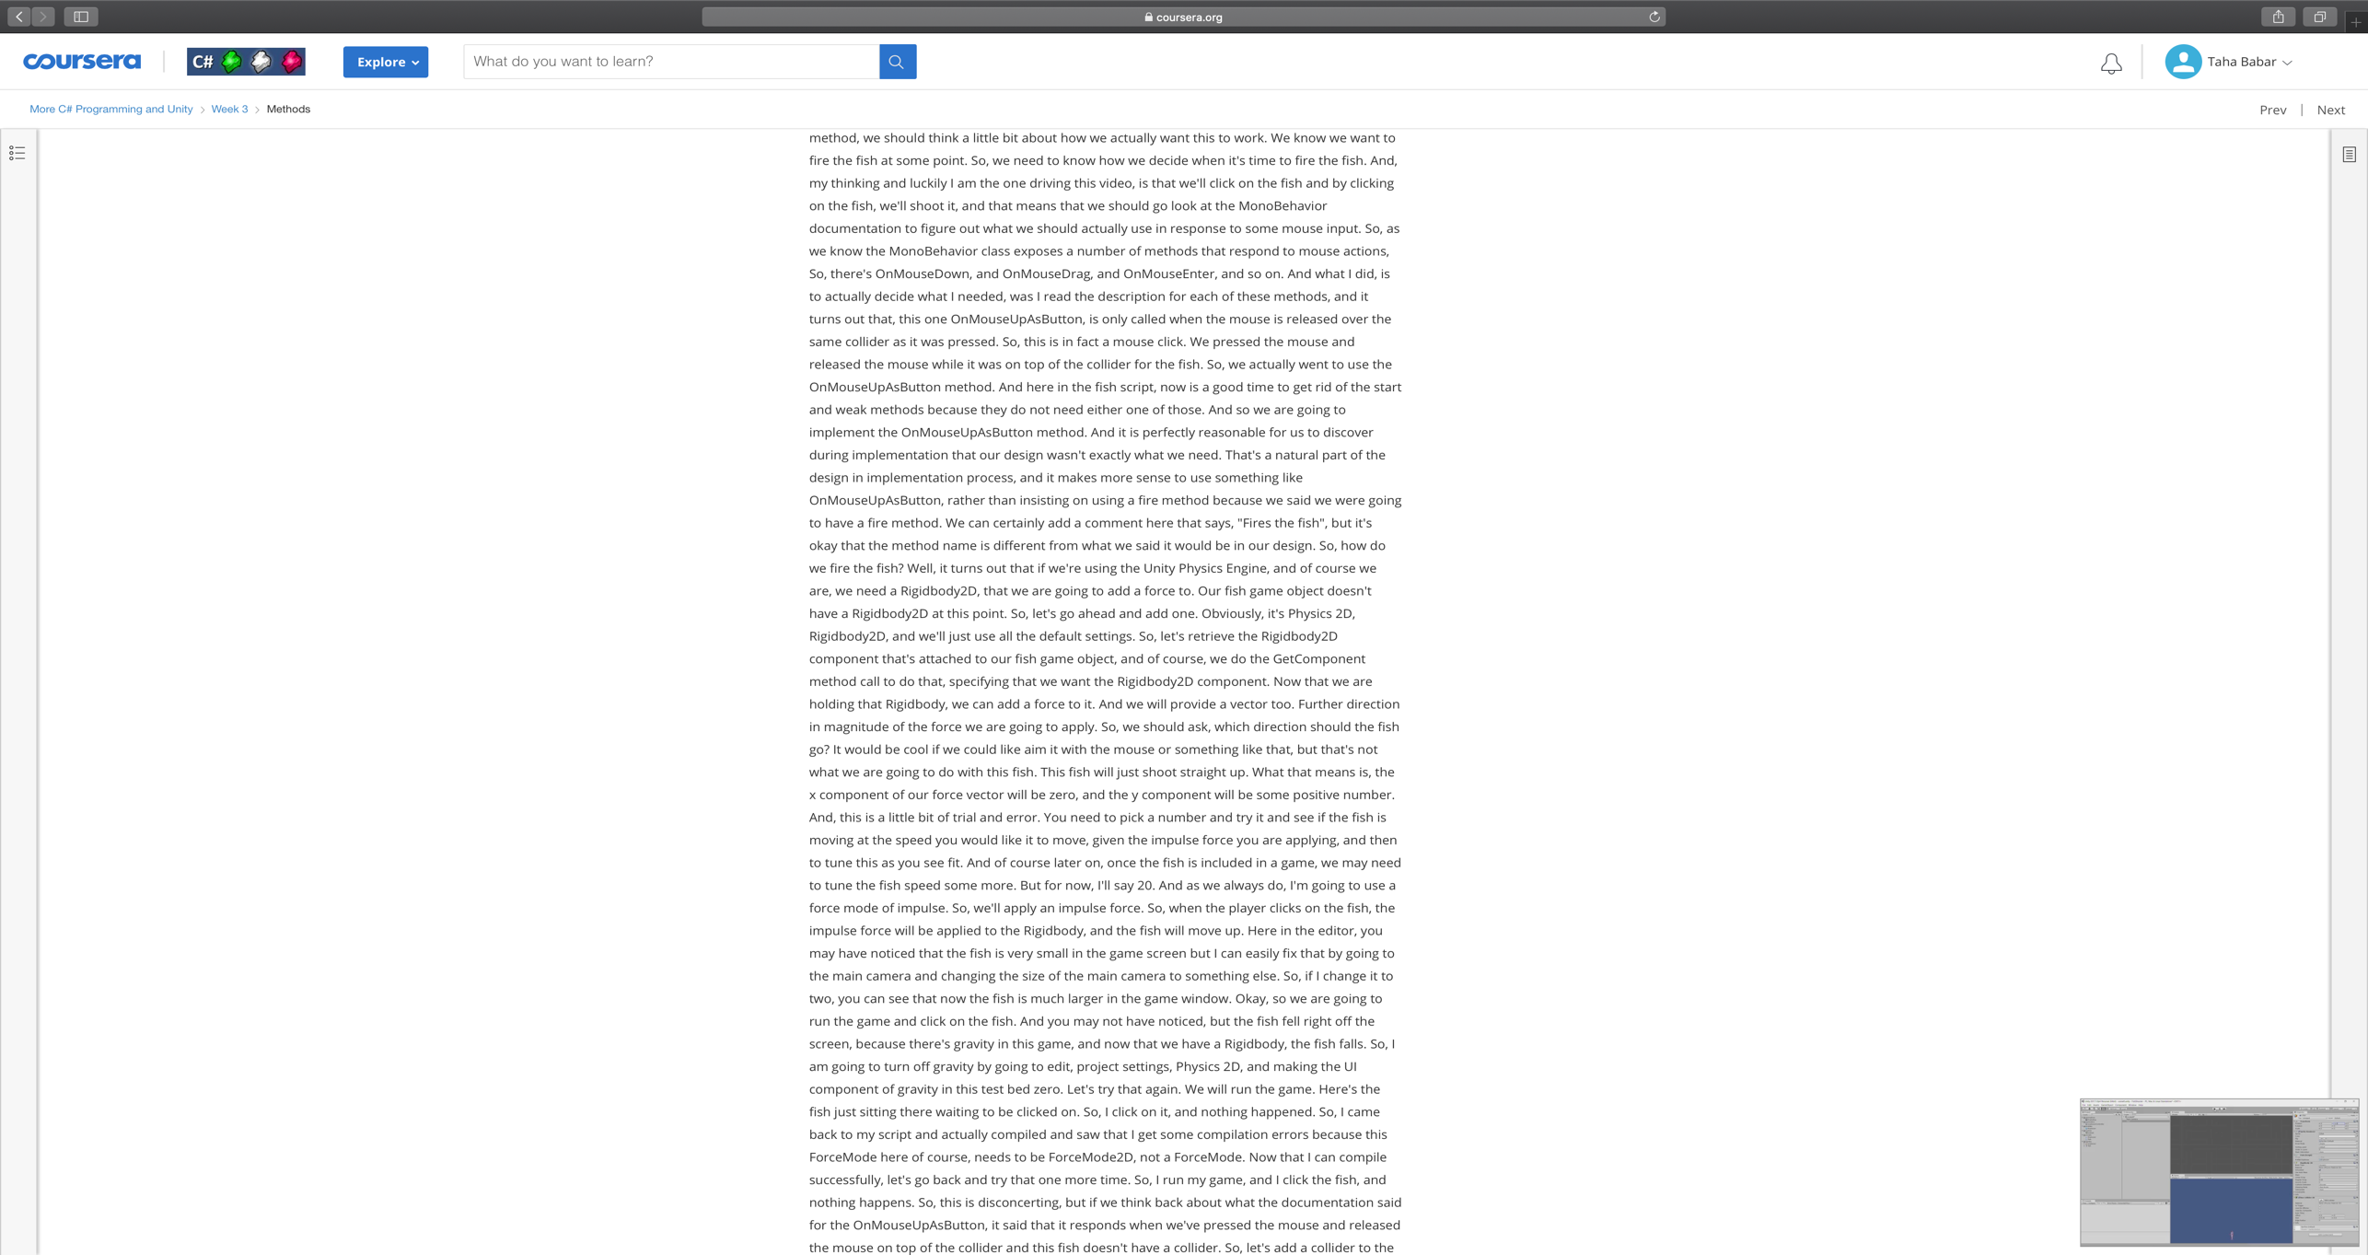

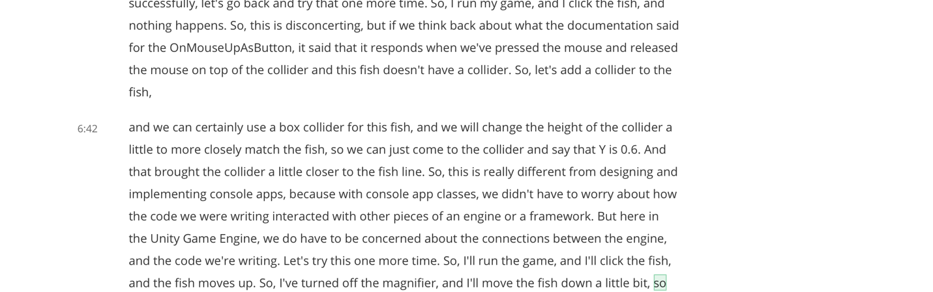

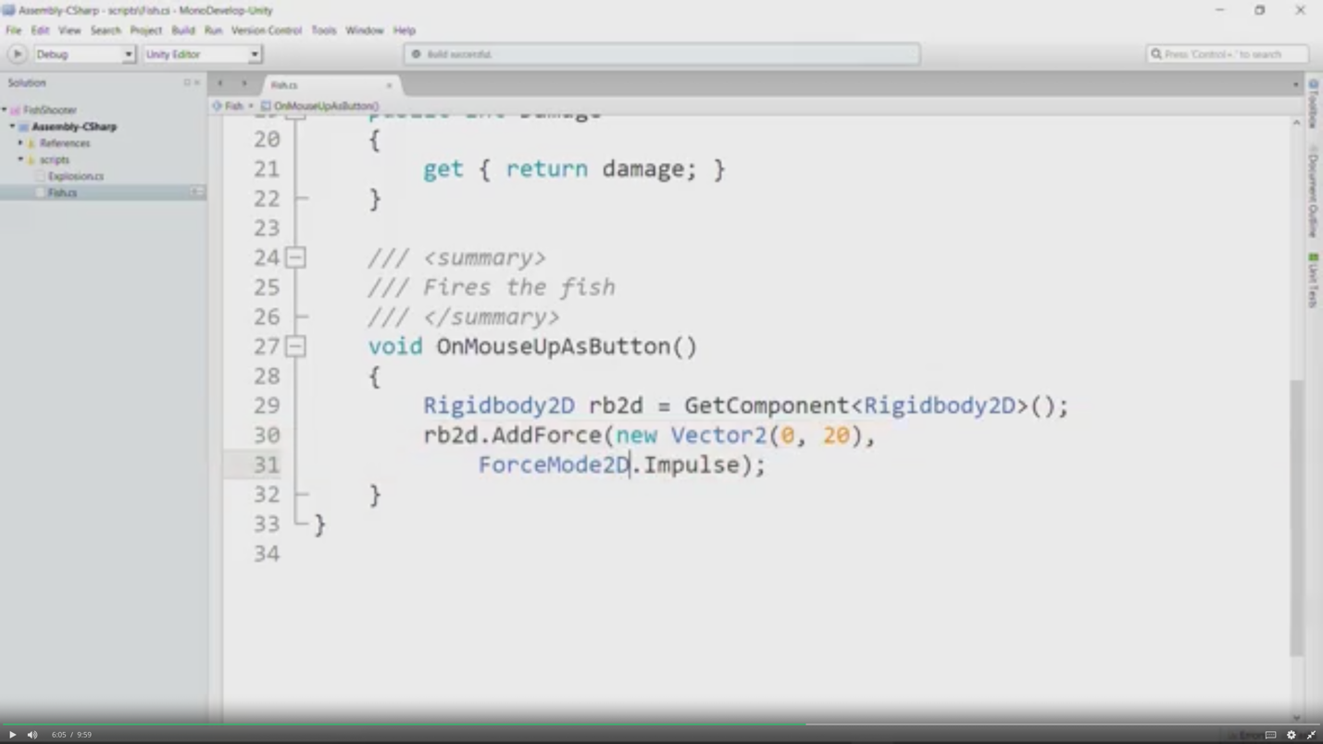

Week 4

Char data type

* In single quotes, unlike strings
* char choice = Console.ReadLine().ToUpper()[0] reads user’s string..converts it into uppercase and then considers the first character in the string, to use later as it is fed in the char choice. E.g. if the string user put was taha….t was saved and we can do if (choice ==’T’) do something etc.

String Basics

* user enters a name and a percent separated by comma. IndexOf helps to locate any character, and not only commas.

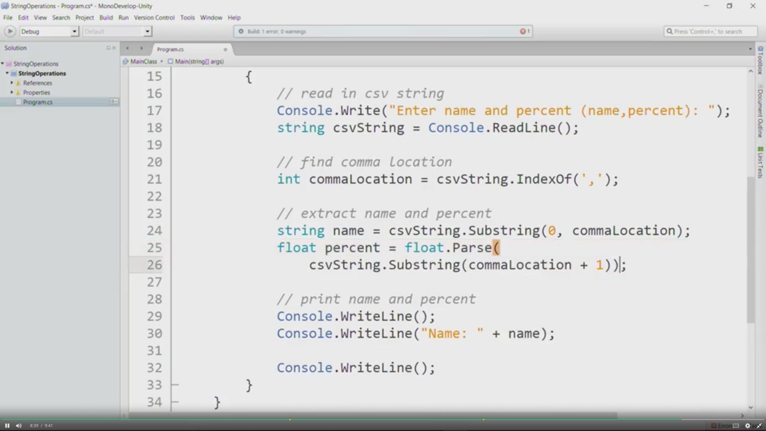

Unity: Other Things that we can do!!

Adding text output that shows score

Demo: <https://www.coursera.org/learn/more-programming-unity/lecture/Jox2A/text-output>

Adding text input to take user’s response

Demo: <https://www.coursera.org/learn/more-programming-unity/lecture/KrPRc/text-input>

Adding Audio and dealing with it

Demo: <https://www.coursera.org/learn/more-programming-unity/lecture/lDU9O/audio-basics>

<https://www.coursera.org/learn/more-programming-unity/lecture/kDNGf/adding-an-audio-manager>